Name: _________________________________ Mark: ____________/22

Physics Unit 4 Evaluation – Age of the universe and Doppler’s shift Time: 40 minutes
The Hubble Time
If we had a movie of the expanding universe and ran the film backward, what would we see? The galaxies, instead of moving apart, would move together in our movie—getting closer and closer all the time. Eventually, we would find that all the matter we can see today was once concentrated in an infinitesimally small volume. Astronomers identify this time with the beginning of the universe. The explosion of that concentrated universe at the beginning of time is called the Big Bang (not a bad term, since you can’t have a bigger bang than one that created the entire universe). But when did this bang occur?
We can make a reasonable estimate of the time since the universal expansion began. To see how astronomers do this, let’s begin with an analogy.
Suppose your astronomy class decides to have a party (a kind of “Big Bang”) at someone’s home to celebrate the end of the semester. Unfortunately, everyone is celebrating with so much enthusiasm that the neighbours call the police, who arrive and send everyone away at the same moment. You get home at 2 a.m., still somewhat upset about the way the party ended, and realize you forgot to look at your watch to see what time the police got there. But you use a map to measure that the distance between the party and your house is 40 kilometres, and you also remember that you drove the whole trip at a steady speed of 80 kilometres / hour (since you were worried about the police cars following you). Therefore, the trip must have taken:
Time = distance / velocity
= 40 kilometres / 80 kilometres / hour
= 0.5 hours
So the party must have broken up at 1:30 a.m.
No humans were around to look at their watches when the universe began, but we can use the same technique to estimate when the galaxies began moving away from each other. (Remember that, in reality, it is space that is expanding, not the galaxies that are moving through static space.) If we can measure how far apart the galaxies are now, and how fast they are moving, we can figure out how long a trip it’s been.
Let’s call the age of the universe measured in this way T₀. Let’s first do a simple case by assuming that the expansion has been at a constant rate ever since the expansion of the universe began. In this case, the time it has taken a galaxy to move a distance, d, away from the Milky Way (remember that at the beginning the galaxies were all together in a very tiny volume) is (as in our example)
T0 = d / v
where v is the velocity of the galaxy. If we can measure the speed with which galaxies are moving away, and also the distances between them, we can establish how long ago the expansion began.
Making such measurements should sound very familiar. This is just what Hubble and many astronomers after him needed to do in order to establish the Hubble law and the Hubble constant. A galaxy’s distance and its velocity in the expanding universe are related by
V = H × d
where H is the Hubble constant. Combining these two expressions gives us
T₀ = d / v = d / ( H × d ) =1 / H
We see, then, that the work of calculating this time was already done for us when astronomers measured the Hubble constant. The age of the universe estimated in this way turns out to be just the reciprocal of the Hubble constant (that is, 1/H). This age estimate is sometimes called the Hubble time.
For a Hubble constant of 20 kilometres / second per million light-years, the Hubble time is about 15 billion years. The unit used by astronomers for the Hubble constant is kilometres / second per million parsecs.
In these units, the Hubble constant is equal to about 70 kilometres / second per million parsecs, again with an uncertainty of about 5%.
To make numbers easier to remember, we have done some rounding here. Estimates for the Hubble constant are actually closer to 21 or 22 kilometres / second per million light-years, which would make the age closer to 14 billion years. But there is still about a 5% uncertainty in the Hubble constant, which means the age of the universe estimated in this way is also uncertain by about 5%.
To put these uncertainties in perspective, however, you should know that 50 years ago, the uncertainty was a factor of 2. Remarkable progress toward pinning down the Hubble constant has been made in the last couple of decades.

AGE OF THE UNIVERSE

- A group of students studying astronomy came across some data relating to the distance D to a galaxy (measured from the Earth) and the velocities v of recession of galaxies from the earth (measured in kms⁻¹). One of the velocity entries in the table is missing.

Galaxy | Distance from Earth, D, (Mpc) | Recession velocity, v (km s⁻¹)
Centre of “Milky Way” | 8 | 280
Virgo cluster | 18 | 2000
RXJ 1242-11 | 198 | 10,000
NGC 4889 |  | 6.48 x 10³
Coma cluster | 90 | 4800
“ Q” | 48 | 4300
“ R “ | 63 | 4850
“S” | 105 | 7000
“T” | 144 | 8900

- Plot a graph of recessional velocity, v (kms⁻¹) versus distance D (Mpc). Plot the velocity on the vertical axis. Calculate the slope of the “line of best fit” in the appropriate units. You should include the origin in your “line of best fit”. (5 marks)

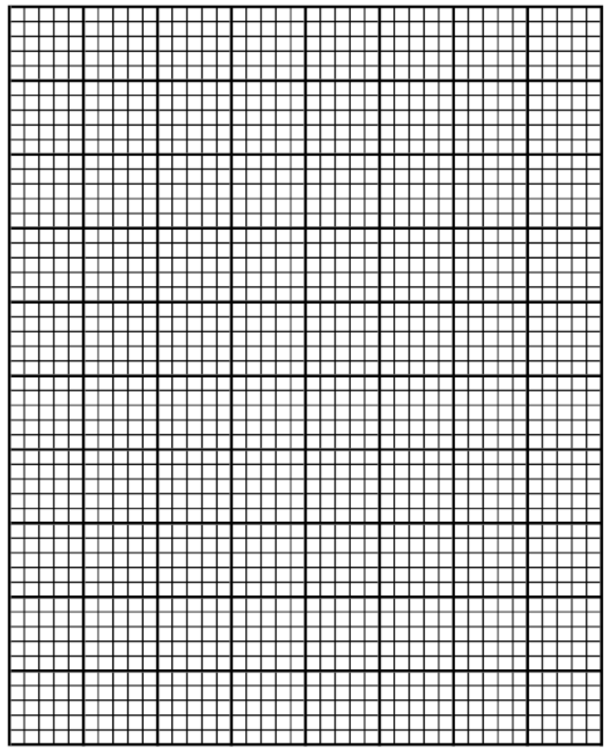

Slope:

- State the relationship between v and D in words. (1 mark)

- Given that the accepted value of Hubble’s constant H is
70.8 (5% ) kms⁻¹ Mpc⁻¹, compare your result for the slope obtained in (i) above with the accepted value. What is the largest percentage error difference between your result and the accepted value for Hubble’s constant? (Assume your slope determination has no error)
(2 marks)

- Calculate to find how many light years make a parsec.
1 Mpc = 1 x 10⁶ pc.
1 Mpc = 3.086 x 10²² m
(3 marks)

- Suggest a reasonable value for the missing entry in the table of data. Indicate how you arrived at the data entry.
(2 marks)

- H allows us to determine the age of the universe. What age in years does your graphically determined value for H indicate the age of the universe to be? (3 marks)

- The Doppler effect is defined as:
The apparent change in wavelength or frequency of the radiation from a source due to its relative motion away from or toward the observer.
- On Earth, the Doppler effect of sound can be easily observed when sound waves move past an observer at a notable speed.
- In space, the Doppler effect of light can be observed when spectra of distant stars and galaxies are observed, this is known as:
  - Redshift if the object is moving away from the Earth, or
  - Blueshift if the object is moving towards the Earth
- Redshift is defined as:
The fractional increase in wavelength (or decrease in frequency) due to the source and observer receding from each other

- For non-relativistic galaxies, Doppler redshift can be calculated using:
- Where:
  - Δλ = shift in wavelength (m)
  - λ = wavelength emitted from the source (m)
  - Δf = shift in frequency (Hz)
  - f = frequency emitted from the source (Hz)
  - v = speed of recession (m s⁻¹)
  - c = speed of light in a vacuum (m s⁻¹)
The spectra below show dark absorption lines against a continuous visible spectrum.
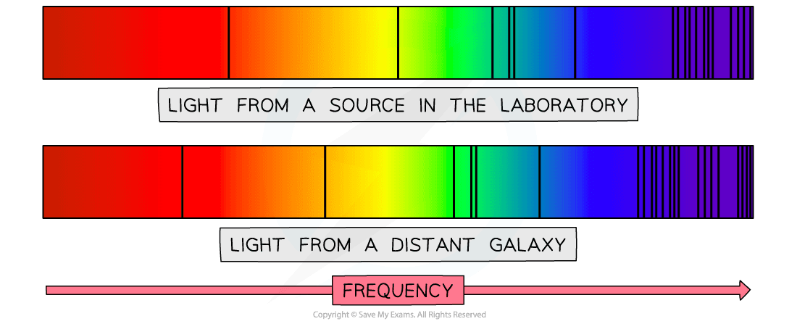
A line spectra for an element in the spectrum of light from a source in the laboratory has a frequency of 5.470 × 10¹⁴ Hz
The line spectra for the same element in the spectrum of light from a distant galaxy has a frequency of 5.447 × 10¹⁴ Hz.
- Calculate the speed at which the distance galaxy moving in relation to the Earth? (4 marks)

- Is it moving towards or away from the Earth? What factors helped you decide? (2 marks)

